Group Members:

Shahzaib Ansar (20P-0473)
Ali Haider (20P-0004)
M Essa (20P-0466)
CN Lab Project (Section A)
Financial Institution System Networking Project
Introduction
Jubilee Financial Services Ltd (JFSL) is a prominent finance service provider in Kenya, headquartered in an eleven-story building in Nairobi. This report details the design and implementation of the network infrastructure for JFSL, aiming to meet the organization's needs for security, performance, scalability, and availability.
The proposed solution ensures a robust, secure, and redundant Local Area Network (LAN) and Wide Area Network (WAN) infrastructure, leveraging modern technologies like VLANs, OSPF, DHCP, and VoIP to enhance functionality and security.
Project Scope
Departments and Device Allocation:
Seventh Floor: HR, Customer Service (CS), and Marketing (MK) with 40 devices, 40 IP phones, and a WiFi-AP per department.
Eighth Floor: Legal Management (LM) and IT with 20 devices, 20 IP phones, and a WiFi-AP per department.
Network Infrastructure Requirements:
VLANs to segregate departmental traffic for enhanced security and performance.
Separate voice VLANs (VID 120) for IP phones.
Hierarchical design model with redundancy at each layer.
WAN Connectivity:
Connections to Safaricom and JTL ISPs for internet redundancy.
Secure communication to external servers hosting DHCP, DNS, WEB, and EMAIL services.
Security Policies:
Use of Access Control Lists (ACL) to control user access.
VPN configuration for secure remote communication.
Network Design
Topological Overview
The network design is based on a hierarchical model, providing:
Core Layer: Comprising multilayer switches for routing and switching.
Distribution Layer: Ensuring VLAN and inter-VLAN routing with high availability.
Access Layer: Comprising access switches for user connectivity.
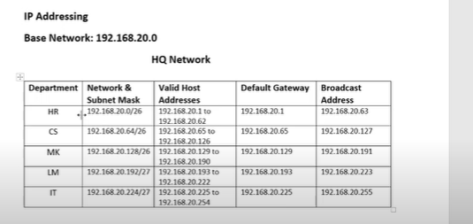

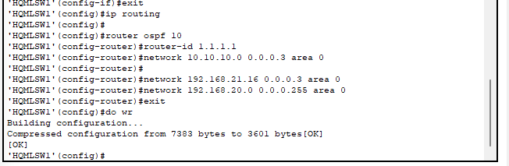
Technologies Implemented
Device Configuration:
Hostnames, passwords, banner messages, and IP domain lookup disabling.
VLANs and Inter-VLAN Routing:
Configured VLANs for each department.
Configured inter-VLAN routing using multilayer switches.
Dynamic IP Addressing:
Dedicated DHCP server for data VLAN.
DHCP configuration on routers for voice VLAN.
Routing Protocol:
OSPF configured for dynamic route advertisement.
VoIP Configuration:
Cisco 2811 router configured for telephony services and VoIP.

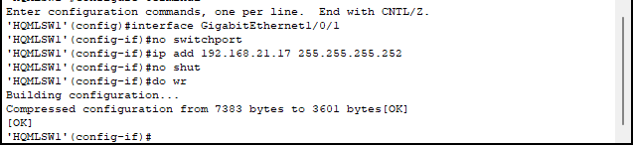
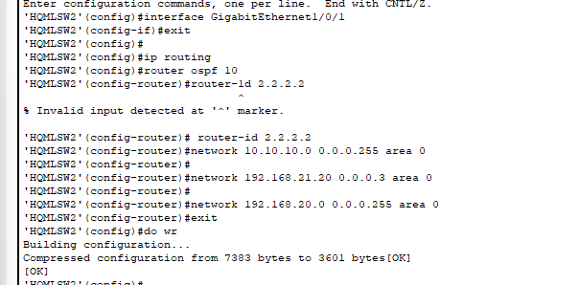

Implementation Details
Subnetting and IP Addressing:
Data VLAN: 192.168.20.0/24
Voice VLAN: 10.10.10.0/24
Public Addresses: 190.200.100.0
Redundancy and Security:
Redundant connections to ISPs for load balancing and failover.
Port security configured on switches using sticky MAC addresses.
Testing and Validation:
Ensured communication between devices in all departments.
Verified internet connectivity and secure remote access using SSH.
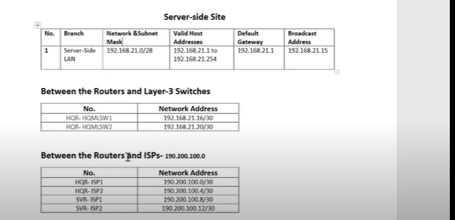

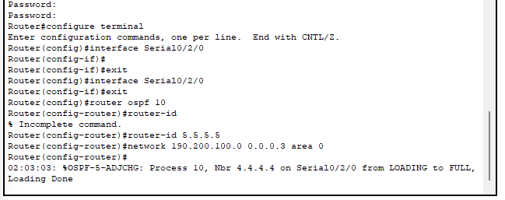
Results
Successful deployment of VLANs with distinct subnet allocations. Functional inter-VLAN routing, DHCP, and VoIP communication. Secure and redundant network infrastructure meeting all design requirements.
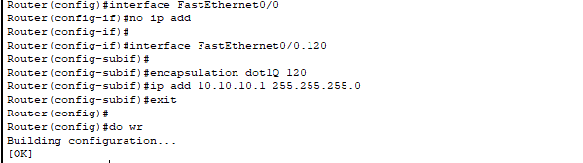

Conclusion
The designed network infrastructure for JFSL meets all requirements for security, scalability, and high performance. The implementation ensures seamless connectivity across all departments and secure communication with external servers, aligning with the organization’s objectives.

<<<<<<<<<<<<END>>>>>>>>>>>>>

